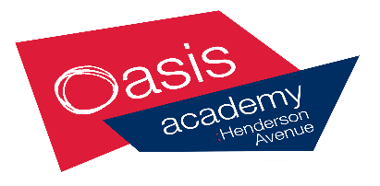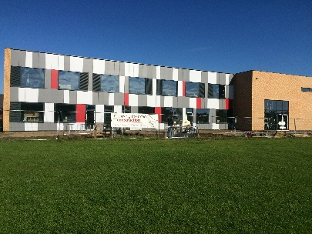

**New Build Newsletter**

As we move into phase 2 of our new building, exciting times lay ahead of us. We are all busy in the academy preparing to pack over 900 boxes in anticipation of moving over the Christmas holidays. This is a mammoth task and all of the academy staff are helping to make this a smooth as possible for all of our pupils.

Although everyone is looking forward to the move, it will come with some changes in how staff, pupils and parents access the academy during phase 2 & 3.

**PHASE 2 – January – March 2016:**

We will only have access to the academy from the two entrances off Spencer Avenue. Unfortunately Henderson Avenue access will be closed to enable the construction company to complete the refurbishment of the Children’s Centre and the part demolition of the school. This decision has not been taken lightly and we have to take into consideration the health and safety of all our families who attend the academy.

There will be 2 entrances off Spencer Avenue, one of them being our current access and the other is where the Galiford Try access is for the new building; it will also be where the access for the temporary staff carpark is. Unfortunately, we **will not** have a carpark for visitors during this time. This will mean there will be a lot of congestion around Spencer Avenue during the start and end of the school day and we kindly ask that you respect the residents around this area. Please do not obstruct their driveways or access to their property. We would suggest that where possible your child walks to school to limit the amount of vehicles along Spencer Avenue and the surrounding area. The access to the Year 1 classrooms will be limited to one pathway

We will also have a limited amount of outdoor space during the phases, and as we have access to the school field we ask where possible, that your child brings wellington boots or a spare pair of shoes with them as the field can be wet at times.

When the pupils return to school on Monday 11th January 2016, we will have staff members on hand to guide you to your child’s new class and help where possible with any questions you may have. Please be assured that all of our pupils and parent’s welfare and safety is taken into account with any decisions we have made and continue to make during the final phases of the new build.

Details regarding phase 3 will be sent nearer the time

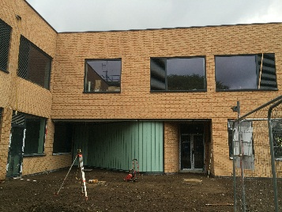

Main entrance into the academy

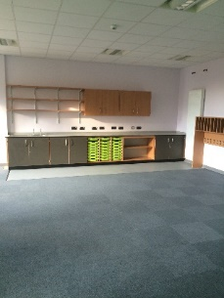

Example classroom

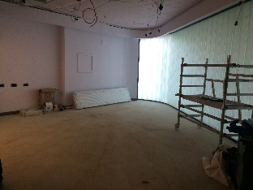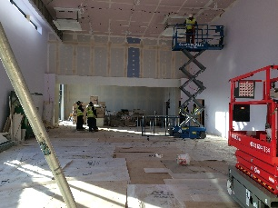

Main Hall Library